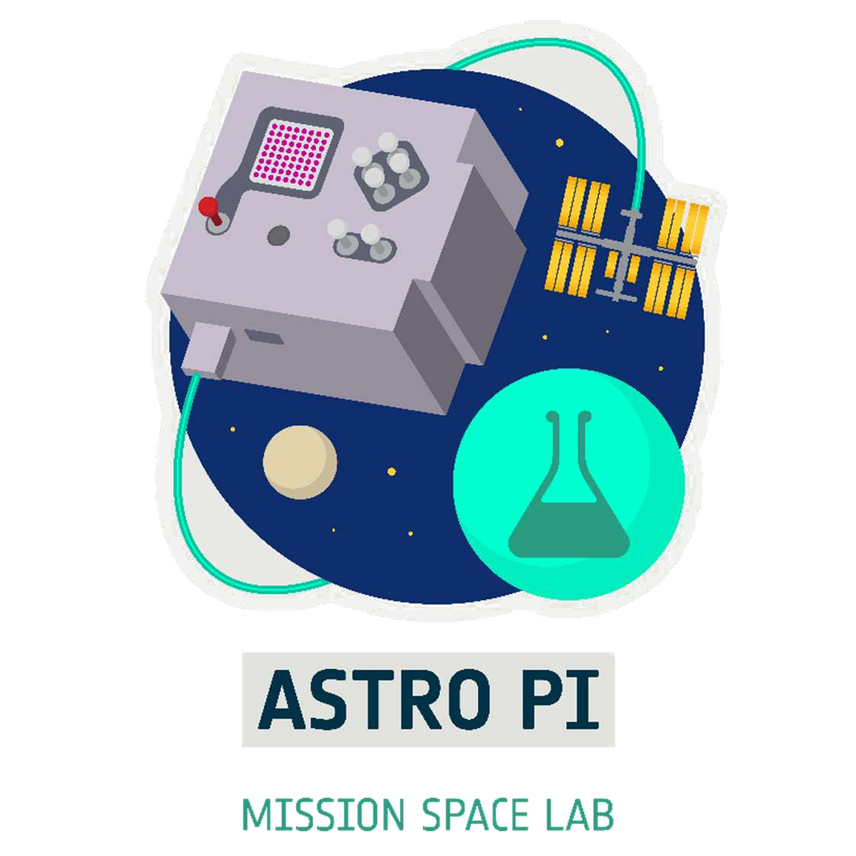

Mission Space Lab Phase 4 Report
Team Name: Atlantes
Chosen theme: Life on Earth
Organisation name: Niubit
Country: Spain

Introduction
Our research aimed to produce music or at least sound with the data collected on the space station by AstroPi Izzy using the sonification technique. We wanted to locate and use open sources of weather data, in order to also be able to sonify the environmental conditions on Earth at the ISS flyby locations. The ultimate goal was to join the sonifications to the photographs taken during the execution of the experiment, to produce stopmotion films.
At the same time, we also wanted that this attractive project to motivate us to learn new techniques and/or improve old ones, as well as manage a long-term project.

Method
During phase 3, our program for Astro Pi Izzy collected every 15 seconds all possible data from the sensors and the station position that it recorded in a CSV file (source 1).
It also recorded pictures of the Earth, which we turned into a new data source by averaging the luminosity and RGB channels values of each picture (source 2).
We analyzed the different sources of weather data that would allow us to locate the environmental conditions on Earth at the points overflown by the station. The best one turns out to be Meteostat. It is free, offers historical data, and has a Python library. We generate a new CSV file with all the weather data that Meteostat offers us at the places and times the ISS overflew during the execution of the program (source 3).
Already in phase 4 we use the 3 data sources mentioned to perform sonifications.
With the pictures we make stopmotion films to which we incorporate the sonifications as a soundtrack.
To sonify we use a fork with modifications of the sonify library. Sonification consists of normalizing the data series to the range [0, 127] which are the possible values for MIDI notes (Figure 1).
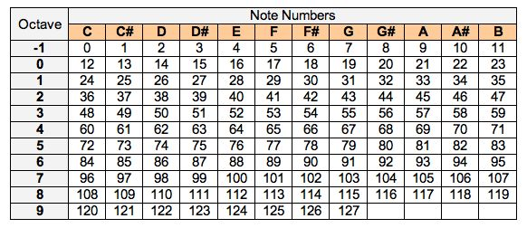Figure 1: MIDI table

Results
To achieve the main objective of the project we needed that at least during part of the route of the station on Earth there were meteorological stations with sufficient density to produce a data set with a non-chaotic variation. First analysis of the data showed that, as expected, this only happens when the ISS flies over land areas, which in our experiment only happened during the American flyby (Figure 4).
Depending on the type of data to be sonified, we select different intervals from the data set. Below are the indexes of the registers that establish the intervals chosen for the different sonifications:
- Complete sequence: 1-713
- American overflight: 307-419
- 1 full orbit with sunlight: 186-431
Although it is not a searched result, the pictures captured by Izzy have also been a find in this project. Below we reproduce some of the ones we liked the most:
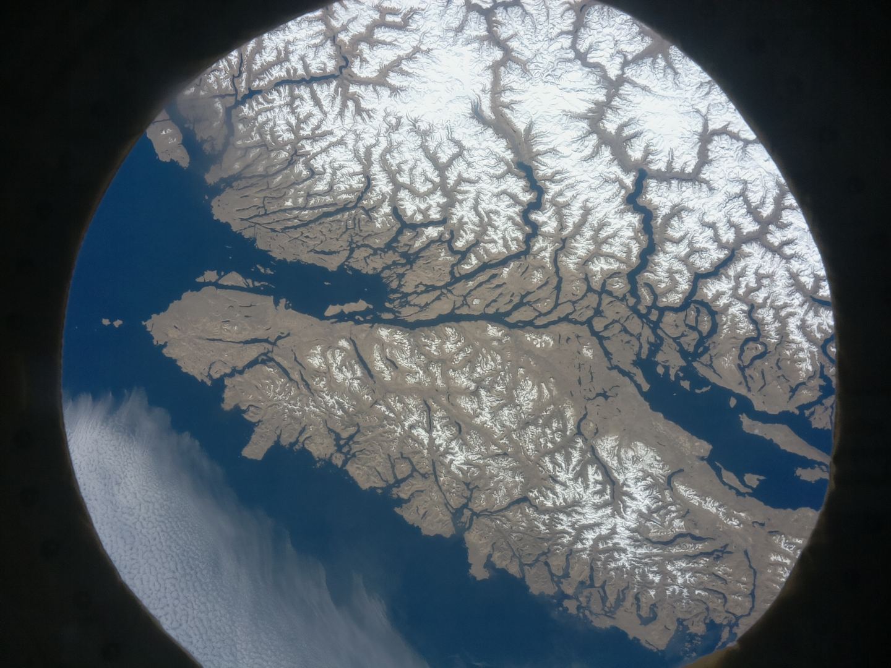Figure 2: #308: Vancouver Island
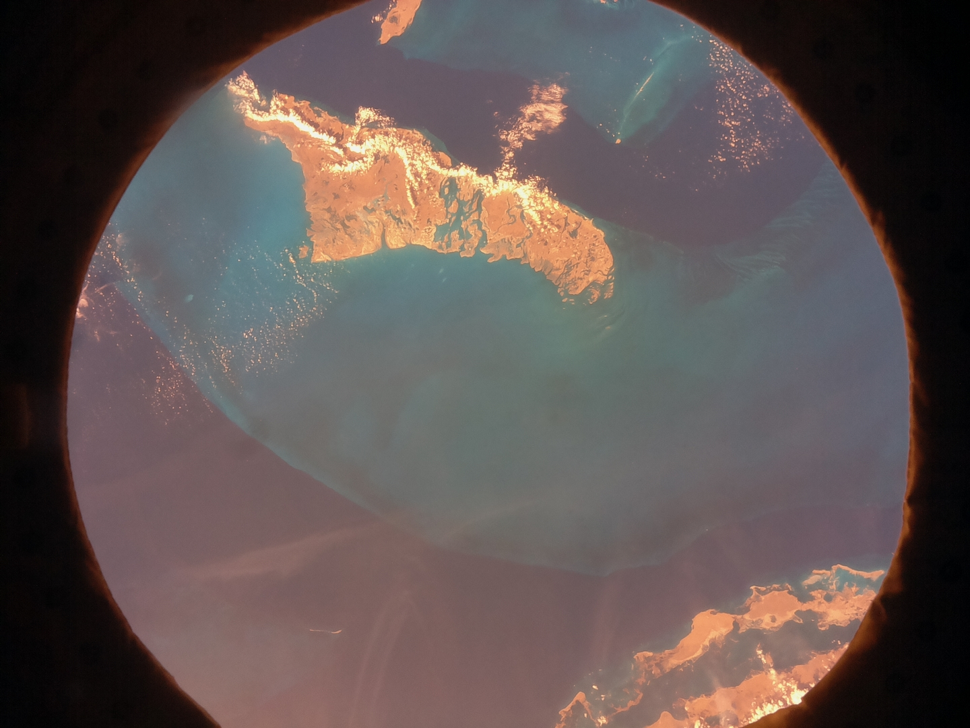Figure 3: #357: Seabed, The Bahamas
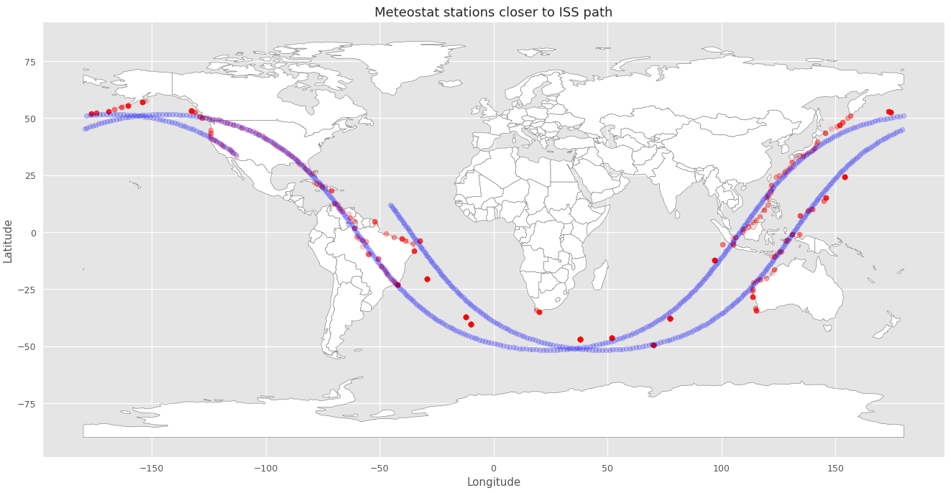Figure 4: Meteostat tracing (blue: ISS; red: Meteostat)
Analyzing the data collected by Izzy and those extracted from the Meteostat library, we reached the conclusion that the best sonification results are achieved with the data observed in Figures 5 to 8.
All the analysis was done with Python code on Google Colab with the notebooks that can be found here: https://github.com/niubit/astropi_atlantes
There is also a link to Google Colab that allows to view the notebook directly: https://drive.google.com/file/d/1OryTH_MUlr3DVNZNsMp2_B1qLQ1i5eqH
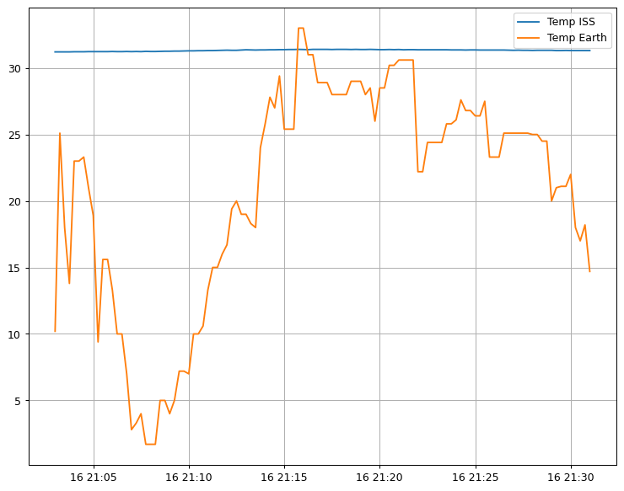Figure 5: Temperature on ISS and Earth https://youtu.be/Hl1exe3S_cI
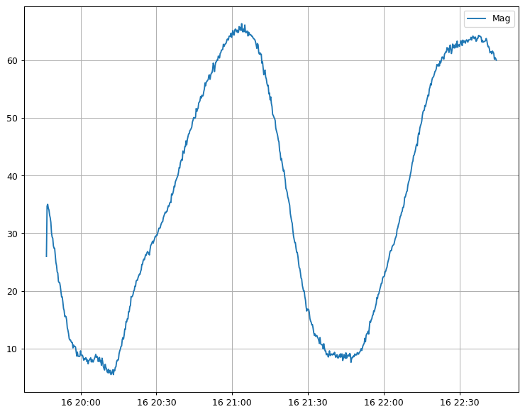Figure 6: Magnetic field intensity https://youtu.be/nXT9t3kGm1o
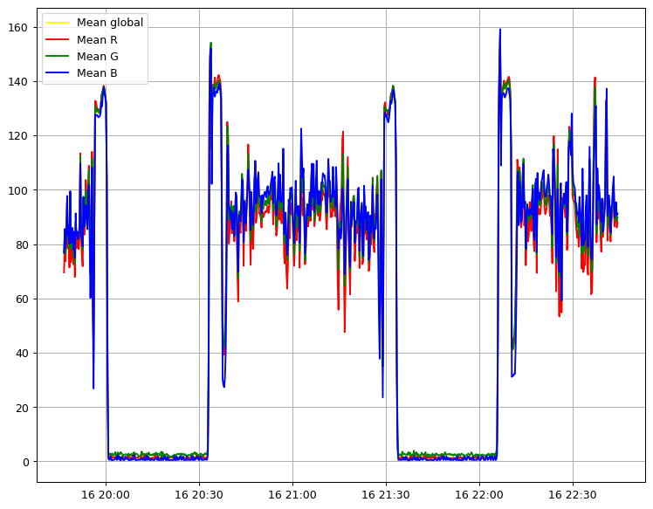Figure 7: Average values for pictures https://youtu.be/SL1XojuapDE
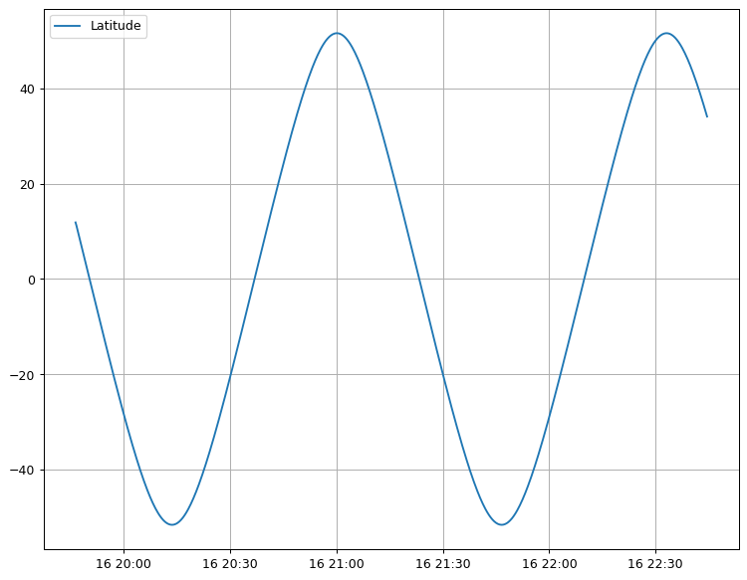Figure 8: Latitude https://youtu.be/G8YluWG5hmw

Conclusion
In conclusion, we can start by commenting that the climatic conditions on Earth along the route of the station have not turned out to be a good source of data to sonify. Certainly being that the amount of surface emerged on our planet is 30%, it was something to be expected. Still, given the amount of data collected, it has been possible to find alternative sources. Some of them, such as the intensity of the magnetic field, have turned out to have an unexpected evolution (highly correlated with latitude) and with an interesting sonification.
On the other hand, the number of meteorological stations on the ground and the historical data that can be obtained with enough precision to follow the course of the station in populated areas is surprising.
Finally, the Jupyter/Google Colab environment has proven to be a very powerful tool for manipulating data in a distributed way and documenting the results.

